ON SEPTEMBER 3Th 2017 FROM 2-12 PM
AT THE ROCKPORT CITY PARK
THE 3rd ANNUAL
BLUES ON THE ROCK
FEATURING: The Beat Daddys, Tullie Brae Band, Bosco France
Laurie Jane & the 45’s, 2 MILES BACK and David Dunavent & Evol Love
Sponsorship Form
Name to be printed on the sponsorship banner, please check one
EVENT $1000
GOLD $500
SILVER $250
BRONZE $100
This is a deductible advertising cost. All sponsorships will be on a banner & displayed!
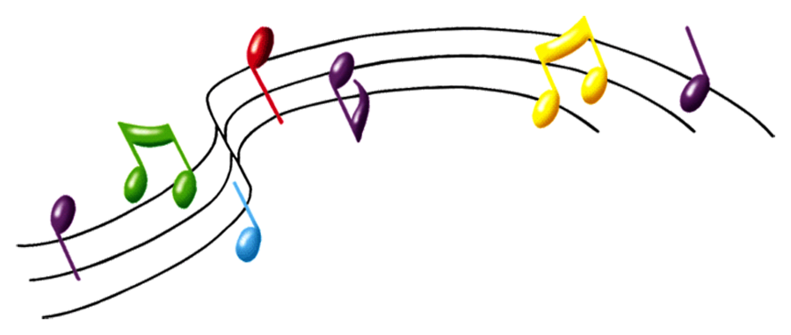
The Hybrid Band will be playing in the beer garden. The McKenzie’s at the Rockport Inn will be there with domestic beer, along with local wineries. Local food vendors will be there with BBQ, brats, hamburgers and more. St. Benedict’s Brew Works will have craft beer.
Part of a series of concerts from the,
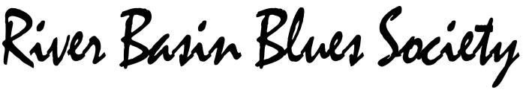
Where musicians, venues, and fans can
Interact to share and promote the Blues
.
Make checks payable to:
ABR, PO Box 302 Rockport Indiana 47635
(ABR) Association for a Better Rockport a 501-c3

